[Date]

Shivam Kushwah

computer programming

PRACTICAL FILE

**INDEX**

1. **Write a program to print sum of 2 numbers**
2. **To find Area of rectangle**
3. **To simpal interest**
4. **To find number is odd or even**
5. **To find greatest among three integers**
6. **(a) To find sum of n numbers using while loop**

**(b) To find sum of n numbers using while loop**

**Practical 1**

**Aim : Write a program to print sum of 2 numbers**

#include<stdio.h>

#include<conio.h>

int main()

{int a,b,sum;

printf ("enter two numbers");

scanf("%d %d",&a,&b);

sum=a+b;

printf("ans:%d",sum);

getch();}

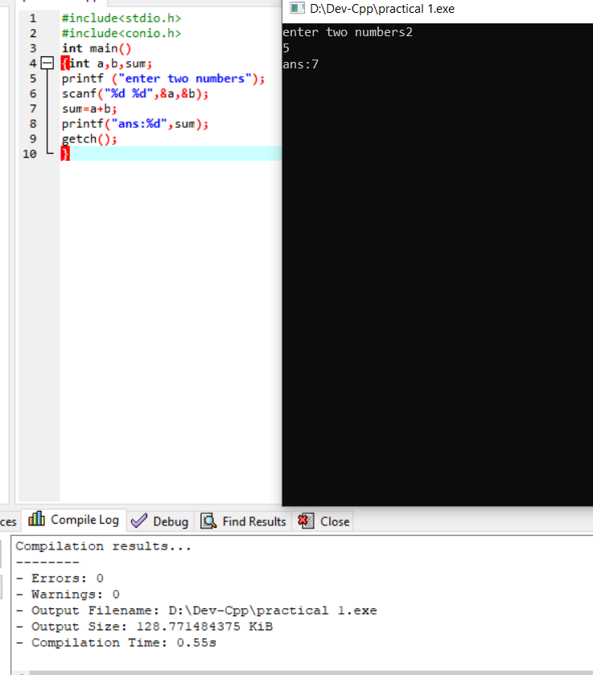}

**Practical 2**

**AIM :To find Area of rectangle**

#include<stdio.h>

#include<conio.h>

int main()

{int a,b,area;

printf("enter two numbers");

scanf("%d %d",&a,&b);

area=a*b;

printf("area:%d",area);

getch();

}

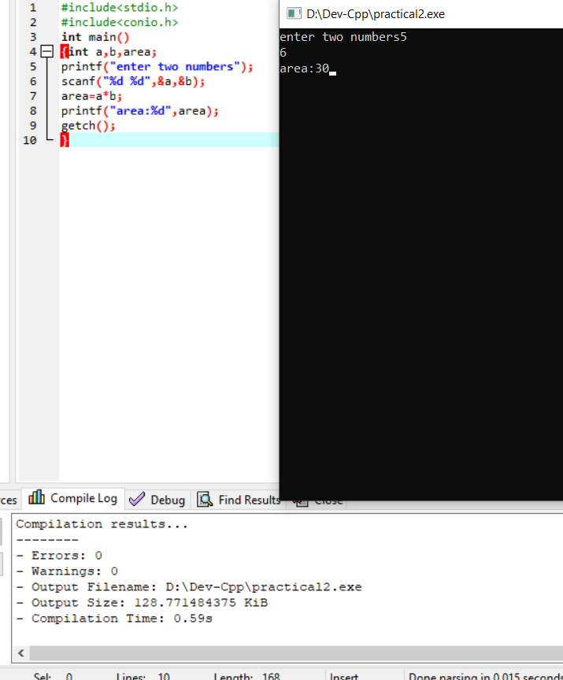

**Practical 3**

**AIM : To calculate simpal interest**

#include<stdio.h>

#include<conio.h>

int main()

{float p, r,t,si;

printf("entre three numbers p,r,t respectively");

scanf("%f %f %f",&p,&r,&t);

si=(p*r*t*0.01);

printf("si:%f",si);

getch();

}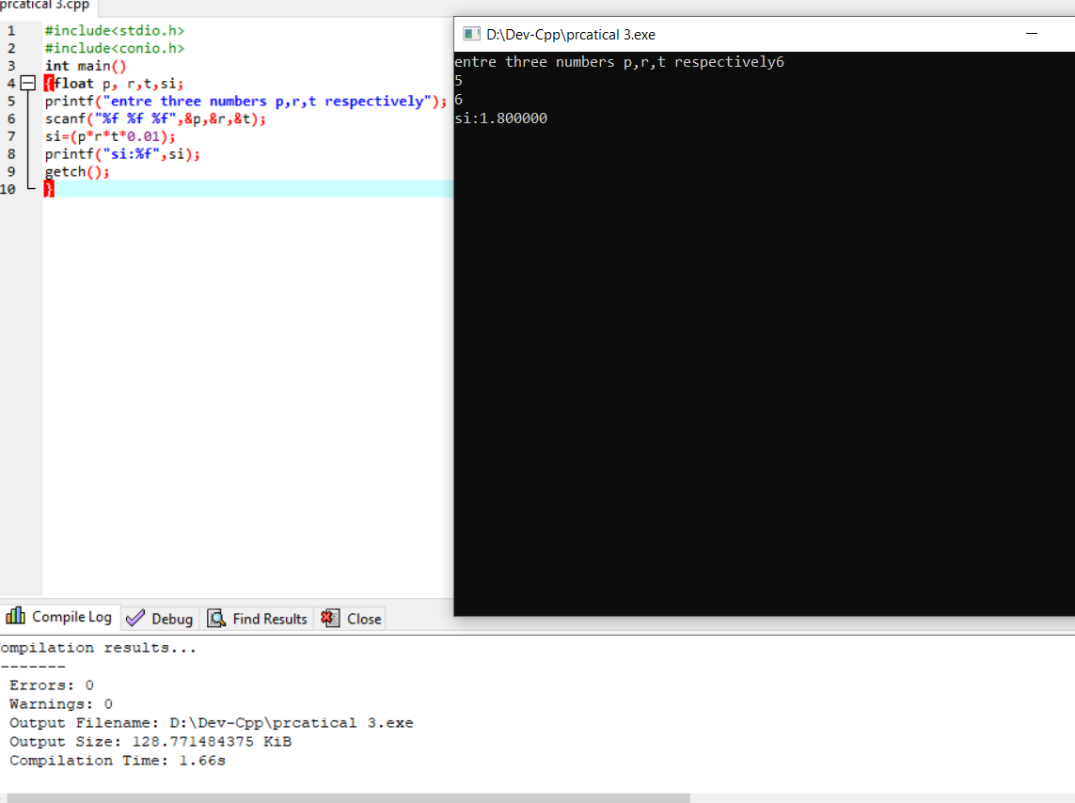

**Practical 4**

**AIM :To find number is odd or even**

#include<stdio.h>

#include<conio.h>

int main()

{int n;

printf("enter number that you want to check odd or even");

scanf("%d",&n);

if(n%2==0)

{

printf("number is even");

}

else

{printf("number is odd");

}

getch();

}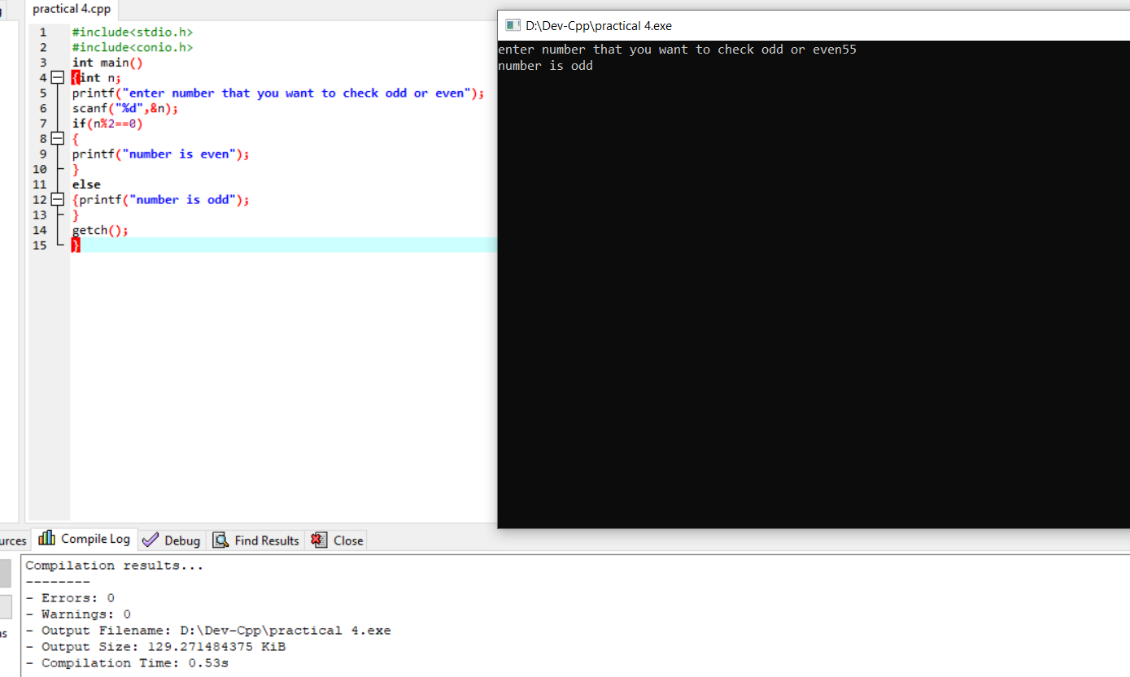

**Practical 5**

**AIM: To find greatest among three integers**

#include<stdio.h>

#include<conio.h>

int main()

{int a,b,c;

printf("enter three numbers a,b,c respectively");

scanf("%d %d %d",&a,&b,&c);

if (a>c&&a>b)

{

printf("a is greatest");

}

else if(b>c&&b>a)

{printf("b is greatest");

}

else if(c>a&&c>b)

{printf("c is gretest");}

else

{printf("number are equal ");

}

getch();}

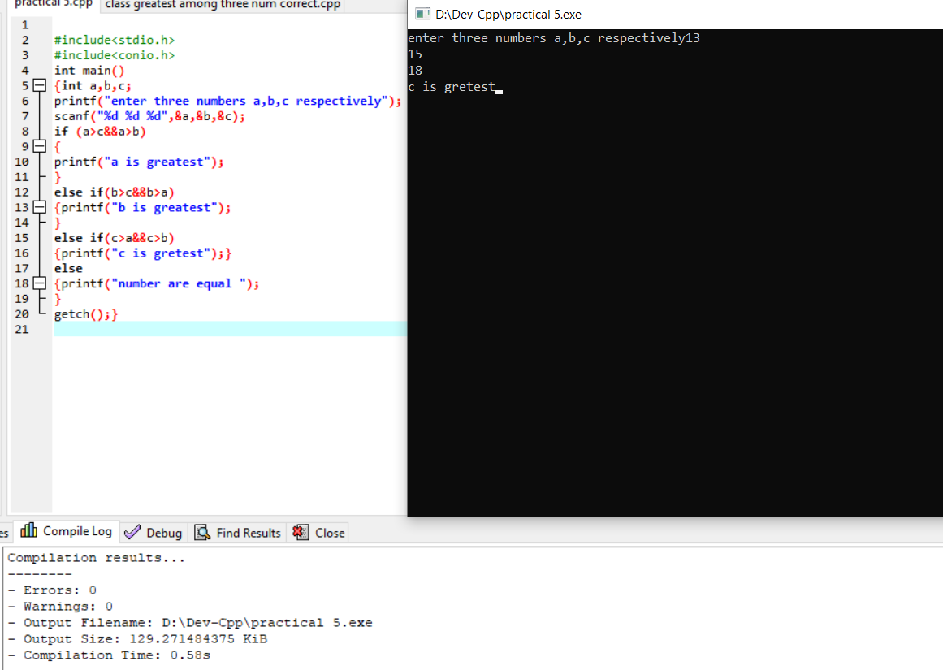

**Practical 6**

**AIM: To find sum of n numbers using while loop**

#include<stdio.h>

#include<conio.h>

int main()

{

int i,n,sum=0;

printf("enter number upto sum you have to find");

scanf("%d",&n);

while (i<=n)

{

sum=sum+i;

i++;

}

printf ("ans=%d",sum);

getch();

}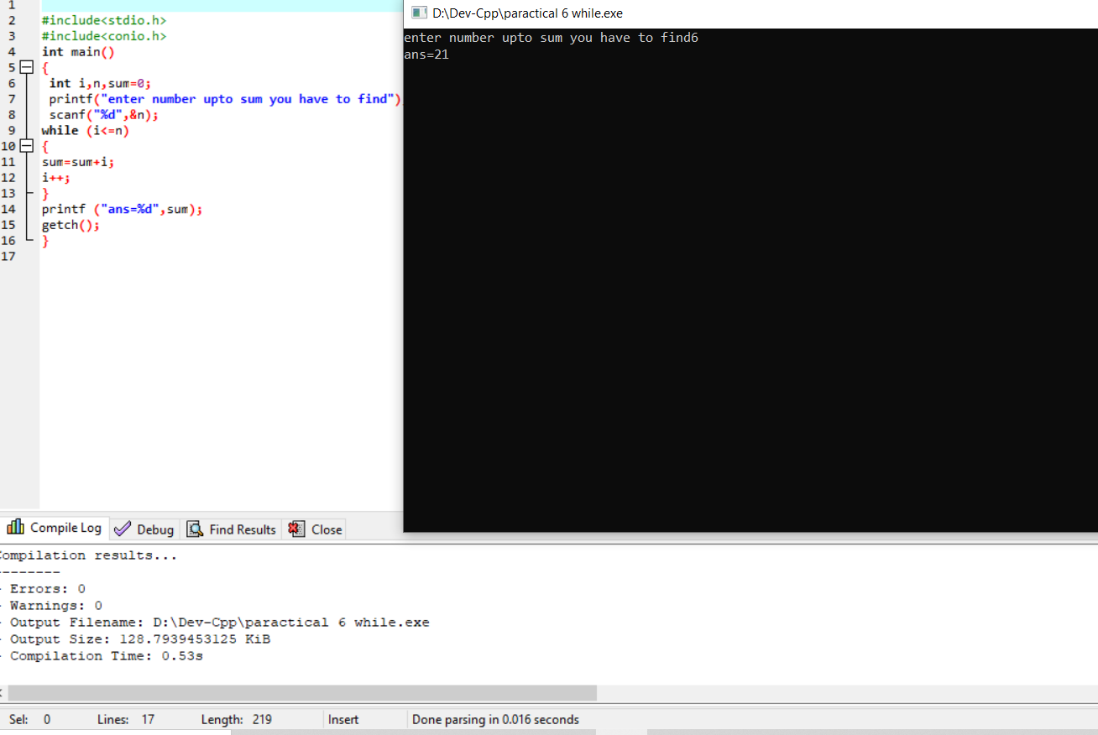

**AIM : To find sum of n numbers using do while**

#include<stdio.h>

#include<conio.h>

int main()

{

int i,n,sum=0;

printf("enter number upto sum you have to find");

scanf("%d",&n);

do

{

sum=sum+i;

i++;

}

while (i<=n);

printf ("ans=%d",sum);

getch() };

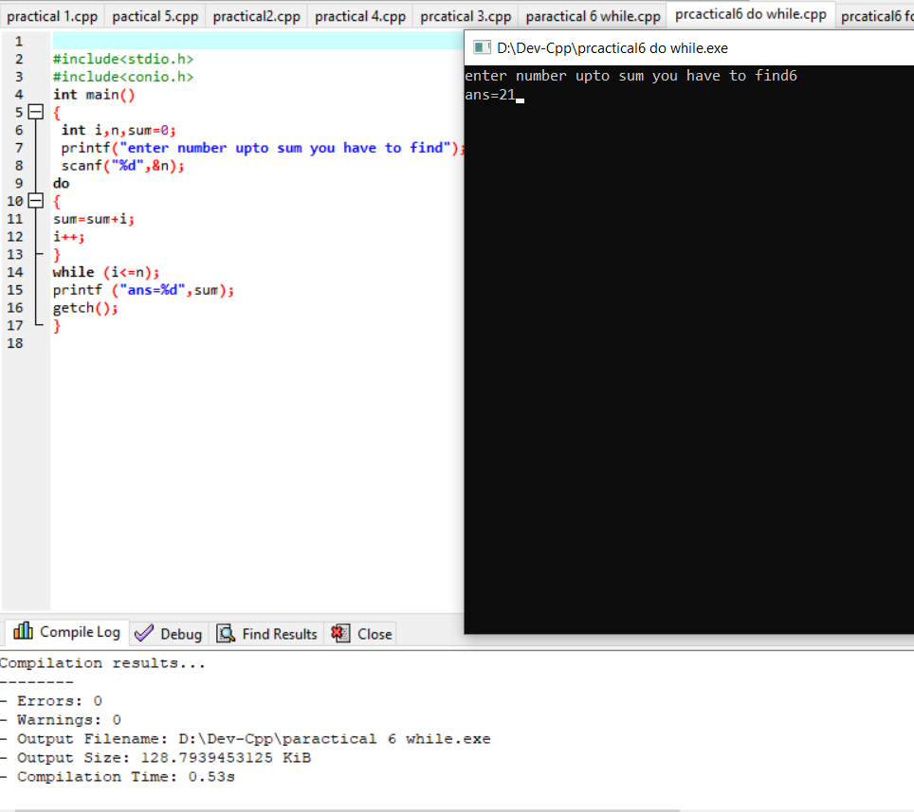

**AIM : to find sum of n numbers using for loop**